Cyber Security of HVDC Systems: A Review of
Cyber Threats, Defense, and Testbeds

ABSTRACT :-

High Voltage Direct Current (HVDC) technology is one of the key enablers of the energy transition, especially for offshore wind energy systems. While extensive research on cyber security of High Voltage Alternating Current (HVAC) systems has been conducted, limited research exists on cyber security aspects of HVDC systems. These systems exhibit unique attributes, in comparison to HVAC systems, such as longer transmission line distances and increased volume of data samples for wide-area monitoring, control, and protection applications. These factors lead to a higher vulnerability of HVDC systems to cyber attacks. Existing state-of-the-art HVDC surveys, however, are primarily focused on HVDC physical components and exclude cyber security elements. Therefore, this paper presents the first detailed survey on the cyber security of HVDC Cyber-Physical Systems (CPS). We present a comprehensive review of the state-of-the-art HVDC systems, with a special focus on cyber threats and vulnerabilities, defense and mitigation strategies, and testbeds. Based on the review and analysis, insights and recommendations on future research directions to address the research gaps in this field of study are provided. Future research on cyber security for HVDC systems should prioritize the integration of cyber and physical system data and focus on early-stage detection to mitigate the potentially severe impacts of cyber attacks on HVDC grids.

Existing System:-

High Voltage Direct Current (HVDC) technology is a key driver for the energy transition, especially offshore wind power integration. Although cybersecurity studies have been widely done on High Voltage Alternating Current (HVAC) systems, HVDC systems are less explored. All the existing research on HVDC systems focuses mostly on the physical and technical aspects, including converters, transmission lines, and grid integration, without paying much attention to cybersecurity.

Existing System. Because of their distinctive characteristics—like higher transmission line distances and more volumes of data samples needed for wide-area monitoring, control, and protection—HVDC systems are more susceptible to cyberattacks than HVAC systems. Nevertheless, existing surveys do not take these threats into account and leave essential research gaps in HVDC cyber-physical security.

Disadvantages of Existing System:

- Existing HVDC surveys concentrate on physical parts and disregard cybersecurity issues.

- Insufficient systematic analysis of the cyber threats, vulnerabilities, and attack surfaces in HVDC systems.

- Growing data exchange demands for HVDC are unsecured and under-studied.

- Lack of holistic methods that bridge cyber and physical system visions.

- Limited emphasis on early-stage prevention and mitigation techniques against cyber threats.

Proposed System:-

The proposed system is the first exhaustive survey on HVDC Cyber-Physical Systems (CPS) that has a specific emphasis on cybersecurity. It surveys cutting-edge HVDC systems, recognizing their characteristic vulnerabilities, cyber attacks, and attack surfaces, and elaborates on defense mechanisms, mitigation controls, and testbed implementations for verification. The method combines both physical and cyber views in order to present a complete picture of HVDC system security. The system also prioritizes early detection and integrated monitoring structures to reduce the possible effects of cyberattacks. Recommendations and insights into future research directions are suggested in order to meet the identified gaps and improve HVDC resilience.

Benefits of Proposed System:

- First in-depth cybersecurity-oriented survey of HVDC systems.

- A comprehensive analysis combining both cyber and physical layers.

- Recognizes cyber threats, vulnerabilities, and risk factors specific to HVDC systems.

- Examines defense techniques, mitigation strategies, and testbed environments for ground-truth validation.

- Encourages early-stage detection frameworks to enhance resilience.

Delivers research findings and recommendations on how to direct future work.

SYSTEM REQUIREMENTS:

HARDWARE REQUIREMENTS:

• System : Pentium IV 2.4 GHz.
• Hard Disk : 40 GB.
• Ram : 512 Mb.

SOFTWARE REQUIREMENTS:

• Operating system : - Windows.
• Coding Language : python.

SYSTEM ARCHITECHTURE:-
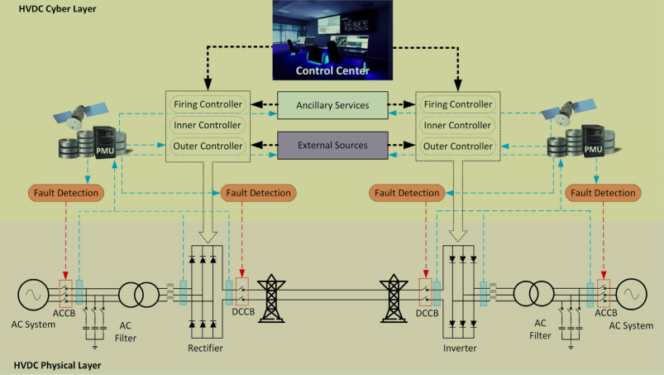

Module Description:-

1. HVDC System Monitoring Module
This module continuously monitors both physical parameters (voltage, current, converter status, transmission line data) and cyber parameters (network traffic, control signals, system logs) of the HVDC system. It ensures real-time visibility into grid operations and detects abnormal behavior across wide-area networks.
2. Cyber Threat Detection Module
This module uses intrusion detection systems and AI-based anomaly detection algorithms to identify cyber threats such as false data injection, denial-of-service (DoS), malware attacks, and command manipulation. It focuses on early-stage detection to prevent disruption of HVDC grid stability.
3. Data Integration Module (Cyber-Physical Fusion)
This module integrates cyber data (communication networks, SCADA commands, logs) with physical system data (electrical measurements). By correlating both domains, it improves detection accuracy and reduces false positives in identifying attacks.
4. Vulnerability Assessment Module
This module analyzes potential weaknesses in HVDC communication networks, control systems, and protection mechanisms. It performs risk assessment and identifies critical components that are highly exposed to cyber threats.
5. Defense and Mitigation Module
This module implements security controls such as encryption, authentication, access control mechanisms, and automated response strategies. When an attack is detected, it initiates mitigation measures to isolate affected components and maintain grid stability.
6. HVDC Cybersecurity Testbed Module
This module provides a simulation environment to model HVDC cyber-physical systems and test various attack scenarios. It allows researchers and operators to evaluate security strategies and validate defense mechanisms before deployment in real grids.
7. Reporting and Decision Support Module
This module generates analytical reports on detected threats, system vulnerabilities, and mitigation effectiveness. It supports operators and researchers with insights for improving cybersecurity policies and strengthening HVDC system resilience.

Functional Requirements

User Functional Requirements
- System Monitoring Access
  - The user shall be able to view real-time HVDC system parameters including voltage, current, and converter status.
  - The user shall be able to monitor network traffic and system alerts through a dashboard interface.
- Threat Detection Viewing
  - The user shall be able to view detected cyber threats such as DoS, false data injection, and command manipulation attacks.
  - The system shall provide detailed information about the type, source, and impact of detected threats.
- Data Analysis and Reports
  - The user shall be able to generate and download cybersecurity analysis reports.
  - The system shall display integrated cyber-physical data analysis results.
- Simulation and Testbed Usage
  - The user shall be able to simulate predefined cyber-attack scenarios in the HVDC testbed environment.
  - The user shall be able to evaluate system behavior under simulated attack conditions.
- Alert and Notification System
  - The user shall receive real-time alerts when abnormal activity or cyber threats are detected.
  - The system shall allow users to configure notification preferences.

Admin Functional Requirements
- Admin Authentication and Role Management
  - The admin shall securely log in to access system configuration settings.
  - The admin shall manage user roles and access permissions.
- System Configuration Management
  - The admin shall configure monitoring parameters for HVDC physical and cyber components.
  - The admin shall update detection rules and security policies.
- Threat Detection Model Management
  - The admin shall upload, update, or retrain AI-based anomaly detection models.
  - The admin shall configure thresholds and sensitivity levels for threat detection.
- Vulnerability and Risk Management
  - The admin shall perform vulnerability assessments of HVDC communication and control systems.
  - The admin shall generate risk assessment reports and implement corrective measures.
- Defense and Mitigation Control
  - The admin shall configure security mechanisms such as encryption and authentication protocols.
  - The admin shall initiate or automate mitigation actions when cyber threats are detected to maintain grid stability.

